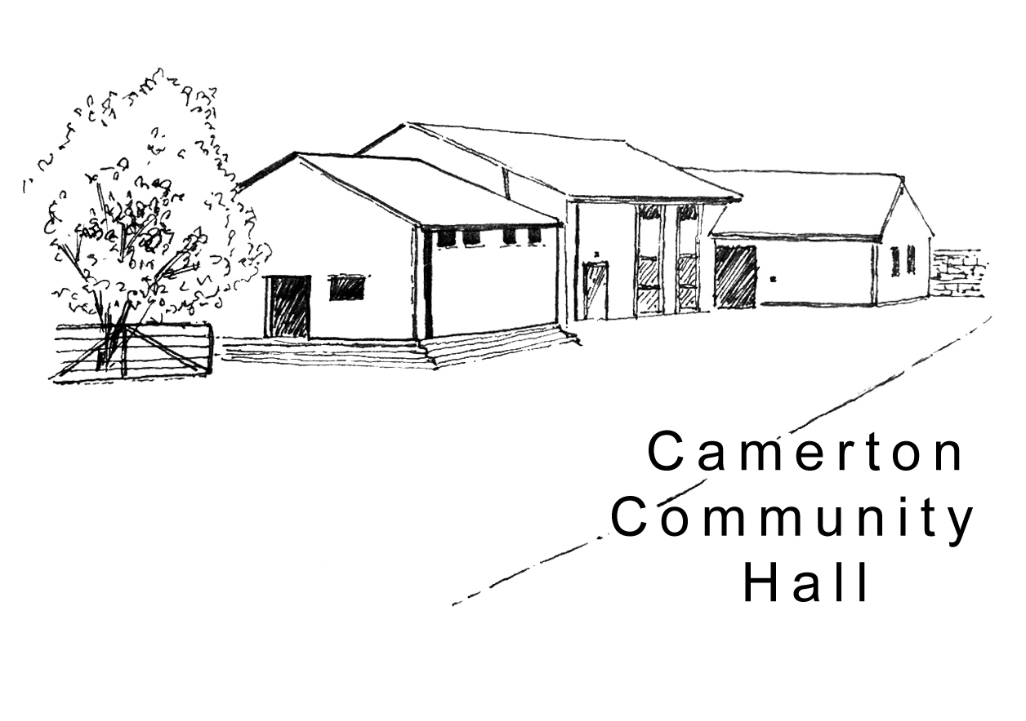

Camerton Community Hall
Registered Charity No. 308263
Wedding Weekend Package – Hall Hire Contract 2020

1. DATE/S REQUIRED
Hire  Start Date  From 12 noon  (Additional hours charged at hourly rate) | Hire  End Date  Until 12 noon  (Additional hours charged at hourly rate) | Celebration Bars - Resident Bar Service  No outside bars/Corkage = £2/Bottle  Wine/Drinks Packages available  NB: Specialist alcohol experience (Gin Bar etc.) must provide copy of their Licence |  | No of Guests Attending
 |  | From: | To:

2. HIRER'S DETAILS
Hirer/Name of overall Responsible Person: .............................................................................................

Home Address:................................................................................................................

……………………………………………………………………………Post Code …….….………………,….

Home Tel: ...........................................................Mobile: .…......…………..……….……………………..…

Email: ......................................................................................................................................................
(We ask for an email address to enable direct communication with you regarding your booking. We will not share/make public personal details)

3. HIRE CHARGE
For bookings confirmed between 1st January-31st December 2020:
Facilities/Period of Hire | Hire Cost
Friday from 12 noon to Sunday at 12 noon | £600 - reviewed annually
Damage/Misuse Deposit | £300 / £600 if camping is required
Use of Field | Included
Use of Catering Oven per hire | Included
Use of Kitchen + Cutlery/Crockery (No glasses) | Included
Camping - including use of a shower  Payable in advance by guests (STRICTLY NO DOGS allowed unless authorised) | £15 per Unit/Night  (A separate booking form should be completed by each Unit)  £3 Electric Hook Up (5 available)

4. PAYMENTS DUE £ Hall Use
Wedding Package Hire Cost | £600.00
Additional Hours Required - £12.50/hr
Total Cost of Booking
(If applicable) Total Cost of Booking less Friends of Hall 10% Discount
PAYABLE TO CONFIRM BOOKING - 50% of Total Cost
BALANCES Payable 6 weeks prior to date of Hire

- Balance Outstanding
DMD Payable 6 weeks prior to date of Hire as separate payment

- Damage/Misuse Deposit (DMD) £300 (or £600 if camping included)

5. HIRE PAYMENTS:

a) Hire Cost

Payment to be made by: BACS (Preferred) [ ] Cheque [ ] CASH [ ]

- 50% Deposit Payment due with completed booking contract to confirm booking (non-returnable)
- BACS to Nat West Bank, Sort Code: 60-14-24 Account Number: 32474628
- Or by Cheque made Payable to: Camerton Community Hall and sent to address below
- Use Payment Reference - Hirer’s name & date of hire (e.g. JSmith 030617)

b) Damage/Misuse Deposit (DMD)

A Separate Payment to be made by: BACS (Preferred) [ ] Cheque [ ] CASH [ ]

- Damage/Misuse due for payment 6 weeks prior to actual date of hire
- Damage/Misuse Deposit will be returned within 10 working days of hire (subject to compliance with T&Cs)
- BACS to Nat West Bank, Sort Code: 60-14-24 Account Number: 55808093
- Or by Separate Cheque Payable to: Camerton Community Hall and posted to address below
- Use Payment Reference - Hirer’s name & date of hire DMD (e.g. JSmith 030617 DMD)

6. INSURANCE
It is advisable to have your own insurance cover.

7. SAFEGUARDING POLICY
Camerton Community Hall is committed to safeguarding and promoting the welfare of children, young people and vulnerable adults and expects all hirers, trustees, members and volunteers to share this commitment.

DECLARATION
I confirm that I am over 18 and that I have read, understood and agree to observe and abide by the Terms and Conditions of Hire and will be personally responsible for the safe conduct of this event and the activities that take place during the period of hire. I have appropriate insurance and first aid cover (if required) and accept Camerton Community Hall’s commitment to the safeguarding of vulnerable groups:

I note that all activities MUST stop at midnight to allow for clearing up/dispersal of guests to comply with the hall’s Licensing Agreement and prevent disturbance of neighbours.

Signed by Hirer: ........................................................... Date: ......................................................

Print Name: ..................................................................

TO SECURE BOOKING YOU WILL NEED TO:

- Complete Booking Form
- Pay deposit of 50% of Booking Charge by BACS/Cheque (email Treasurer to confirm you have paid)
- Read and sign a copy of the Terms and Conditions

Please return Booking Form with Hire Payments, if cheques, to:

Maggie Hutton, CCHT, Long Acre, Durcott Lane, Camerton BA2 0QE
camertoncommunityhalltreasurer@outlook.com

You will receive confirmation of booking by email as soon as all paperwork and initial payments have been received.

Thank you.
We hope you enjoy using our facilities and have a successful event

Camerton Community Hall, Meadgate, Camerton, Bath BA2 0NL
Registered Charity No. 308263
www.camertoncommunityhall.co.uk
August 2019

