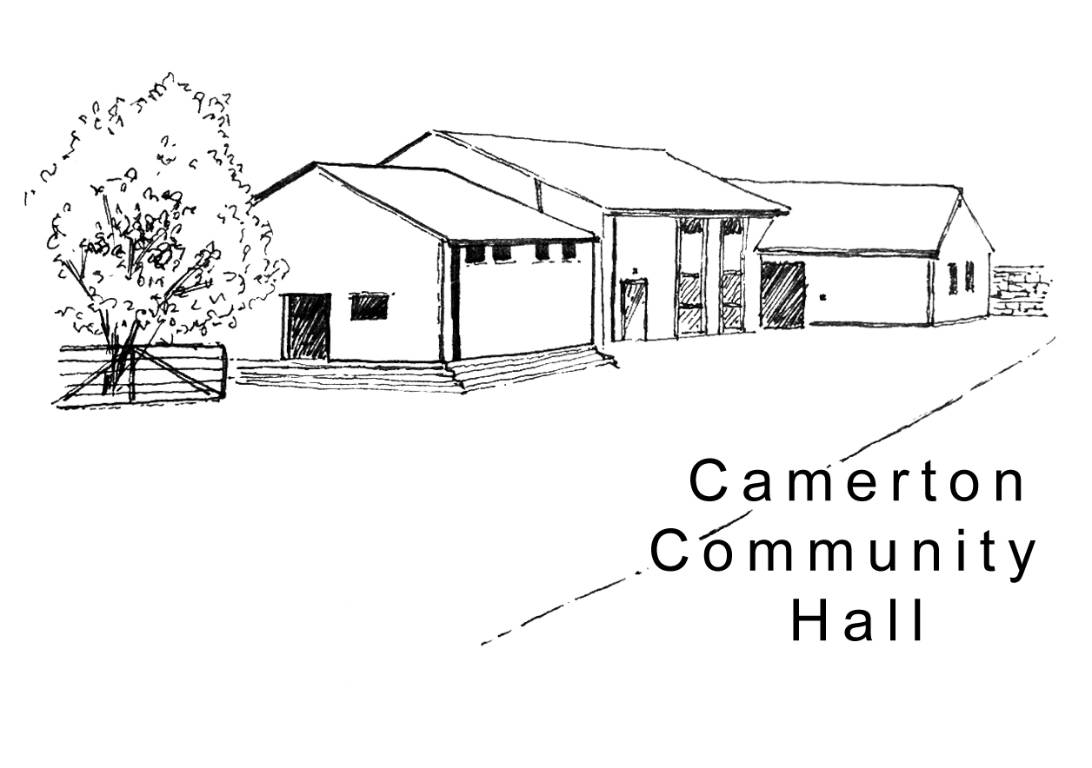

Camerton Community Hall
Registered Charity No. 308263
Single Use Hire Contract 2021

1. DAY / DATE / TIMES OF HIRE REQUIRED
Day | Date Required | Hall Hire Period  (To include setting up & clearing) |  | Hours | Resident Bar Service Required (no charge)
 |  | Start: | End: | Total | From: | To:

2. PURPOSE OF HIRE Approx. No. attending (200 max)

3. HIRER'S DETAILS
Organisation (if applicable): ...................................................................................................................

Hirer/Name of overall Responsible Person/Organisation if any: ..............................................................

Address: ...................................................................................................................................................

……………………………………………………………………………Post Code ……….…………….……..

Personal: ..................................................................................Business: .…......…………………..…..…

Email: .....................................................................................................................................................
(We ask for your email address to enable communication directly with you. We do not share or make public your personal details)

4. HIRE CHARGES for events held in 2021
Facilities/Period of Hire | No. of Hours Required | Hire Charge | Sub Total  £
HALL
Hourly Rate (2 hours minimum) Mon-Fri til 6pm + Saturday/Sunday & except hours listed below |  | £12.50
Friday Parties & Weddings: -  - 6pm-midnight |  | £150.00
Friday – all other events: -  - 6pm-midnight |  | £120.00
Saturday: -  - All day til Midnight |  | £300.00
Saturday: -  - 6pm-midnight |  | £150.00
Sunday: -  - All day til 10.30pm |  | £250.00
Use of Catering Oven per session |  | £10.00
Use of Field (including own marquee) Per day |  | £50.00
Bar Area |  | By arrangement
Camping |  | By arrangement

2

5. SPECIAL OFFERS (Please tick if applicable):

Camerton Residents & Friends of Camerton Community Hall | 10% Discount

6. PAYMENTS DUE
Hire DDMB
Total Cost Due | £ | £

50% of Total cost of Hire Non-Returnable payment to secure booking

Damage/Misuse Deposit (DMD) - Payable 6 weeks prior to hire
as a separate payment by cheque, cash or BACS clearly marked ‘DMD’ on envelope or transfer: -
- Hourly Bookings per event - £50
- All Day/Evening Events - £150
- 21st Parties (strictly no 18th parties allowed) - £300
- Camping/Other Special Events – Price on Application

Final payments due 6 weeks prior to the date of actual hire

7. HIRE PAYMENTS:

a) Hire Cost
Payment will be made by: BACS (Preferred) [ ] Cheque [ ] CASH [ ]

- 50% Deposit Payment due with completed booking contract (non-returnable)
- BACS to Nat West Bank, Sort Code: 60-14-24 Account Number: 32474628
- Payment Reference - Hirer’s name & date of hire (e.g. JSmith 030617)
- Cheque/s payable to Camerton Community Hall and sent to address below

b) Damage/Misuse Deposit
Separate Payment will be made by: BACS (Preferred) [ ] Cheque [ ] CASH [ ]

- Payment due 6 weeks before hire date
- Damage Deposit/Misuse Bond will be returned within 10 working days of hire (subject to compliance with T&Cs)
- BACS to Nat West Bank, Sort Code: 60-14-24 Account Number: 55808093
- Payment Reference - Hirer’s name & date of hire (e.g. JSmith 030617)
- Separate Cheque payable to Camerton Community Hall and posted to address below

8. INSURANCE
It is advisable to have your own insurance cover if you are having a bouncy castle or similar equipment (with permission from management committee).

9. SAFEGUARDING POLICY

b) Policy

Camerton Community Hall is committed to safeguarding and promoting the welfare of children, young people and vulnerable adults and expects all hirers, trustees, members and volunteers to share this commitment.

3

b) Events for under 21s

If you are organising an event for Under 21 years, please complete the full contact details of two additional adults.

RESPONSIBLE ADULT SUPERVISOR (21 or over) No. 2:

Name ..........................................................................................

Home Address: .......................................................................................................................................

…………………………………………………………Phone: .....................................................................

RESPONSIBLE ADULT SUPERVISOR (21 or over) No. 3:

Name ................................................................................................

Home Address: ........................................................................................................................................

…………………………………………………………Phone: ......................................................................

DECLARATION

I confirm that I am over 18 and that I have read, understood and agree to observe and abide by the Terms & Conditions of Hire (see www.camertoncommunityhall.co.uk/rentals and the attached Appendix –
Hirer’s Responsibilities - 10 Essentials).

I will be personally responsible for the safe conduct of this event and the activities that take place in association with the booking/period of hire.

I have appropriate insurance and first aid cover (if required) and accept Camerton Community Hall’s commitment to the safeguarding of vulnerable groups:

Signed by Hirer: ........................................................... Date: ......................................................

Print Name: ..................................................................

TO SECURE BOOKING YOU NEED TO:

- Complete Booking Form
- Pay deposit of 50% of Booking Charge by BACS (email Treasurer to confirm you have paid) or by cheque

Return booking form, cheque and cash payments to:

Maggie Hutton, CCHT, Long Acre, Durcott Lane, Camerton, BA2 0QE camertoncommunityhalltreasurer@outlook.com

You will receive confirmation of booking by email once all paperwork and initial payments have been received.

Thank you.
We hope you enjoy using our facilities and have a successful event

Camerton Community Hall, Meadgate, Camerton, Bath BA2 0NL
Registered Charity No. 308263
www.camertoncommunityhall.co.uk
August 2019

Appendix

Camerton Community Hall

The Camerton Community Hall Management Committee manages the Hall and its grounds. Hirers must look after the facilities, collect and leave keys as required and leave the venue in a clean and tidy condition.

Failure to comply with any of your contractual responsibilities listed below could result in some/all of your Damage Misuse Bond being withheld.

HIRERS RESPONSIBLITIES - 10 Essentials

- Maximum number of people must not exceed 200. The Hirer is responsible for the Hall during the hire period and must be present and responsible for the event at all times.

- Insuring his/her own activities. Events involving young people under the age of 21 must be supervised by a minimum of three adults aged 21 and over.

- It is a residential area – please keep noise down and to an absolute minimum outside the hall, especially late at night including in-car music, shouting, screaming and rowdy behaviour. YOU will be held responsible for your guests conduct on or around the hall.

- No alcohol to be personally brought onto the premises where a bar under licence has been booked.

- You must familiarise yourself with Fire Exits and foam/dry fire extinguishers. Fire Exits/corridors must not be obstructed at any time. Battery operated candles/tea lights ONLY to be used.

- NO DOGS ALLOWED – on hall property including the field, car park and copse areas, unless authorised.

- No pins, staples, adhesive etc. to be attached to the fabric of the hall. Blu-Tack can be used and hooks are provided. No extra lighting, extensions, heating appliances or other electrical equipment must be used without prior consent of the Committee.

- As stipulated by the local authority, A NOISE LIMITER governing device will cut out electric in the event of extreme levels of sound. Please bring TO THE ATTENTION OF the Band, DJ or entertainment.

- The Hall, kitchen and bar areas to be left in a clean and clear state. ONLY non-abrasive cleaning materials to be used. The hirer must NOT attempt repair work.

- You must bring your own black bin bags and ALL rubbish and recycling MUST be taken away from the hall premises/grounds on leaving so as not to affect return of your full Damage Deposit/Misuse Bond. Outside bins are for ‘Hall use only’ and are not for use by the hirer. The Hirer is responsible for vacating everyone and everything from the Hall by the time stated, ensuring all equipment is turned off and doors/windows locked. Please remove all rubbish and effects.

Full Responsibilities are detailed in the Hall’s Terms and Conditions of Hire
to be seen at www.camertoncommunityhall.co.uk

