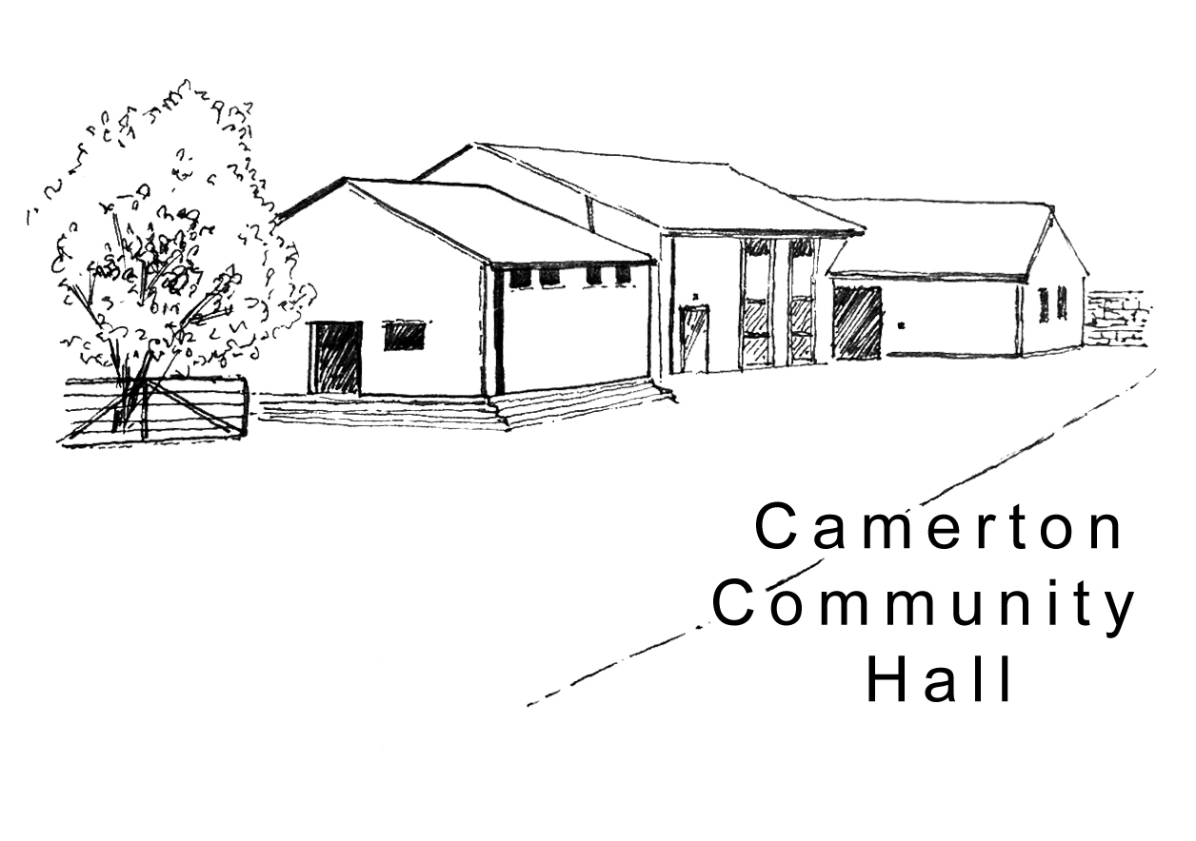
Camerton Community Hall
Registered Charity No. 308263

Regular Use Hire Contract 2021

1. HIRER'S DETAILS

Organisation (if applicable): .............................................................................................................

Name of Person Responsible: ...........................................................................................................

Business / Home Address (as applicable): .........................................................................................

…………………………………………………………………………………………………………………..

Phone - Home: .................................................Business: …......…………...…………………………...

Email: .................................................................................................................................................
(We ask for your email address to enable communication directly with you. Please see Privacy Statement on website).

2. PURPOSE OF HIRE: Approx. No. attending (200 max):

3. DAY/S / TIMES OF HIRE REQUIRED (2 hrs. minimum):
Day of Week | Date From: | Date To: | Time/s  (To include setting up & clearing)  Start: End:

4. FUNCTION AREA/S & FACILITIES REQUIRED (Please tick):
Hall &  Car Park |  | Kitchen |  | Use of Catering Oven |  | Field

5. HIRE CHARGES:

- Mon-Fri 6pm + Sat & Sun - £12.50 per hour – 2 hours minimum (8am-6pm only)
- Catering Oven - £10 per hire if required

2

6. PAYMENT TERMS:

- Payment, preferably by BACS, due at the end of each month on invoice
- Payment Reference - Please provide name and/or organisation
- Cheque payable to Camerton Community Hall sent to address below

7. INSURANCE:

Please provide evidence of appropriate current Insurance Cover.

8. SAFEGUARDING:

Camerton Community Hall is committed to safeguarding and promoting the welfare of children, young people and vulnerable adults and expects all hirers, trustees, members and volunteers to share this commitment.

If you/your organisation works with Children & Young People or Vulnerable groups, please ensure that a Disclosure and Barring Service check is obtained for any eligible adults. Further information on can be found at www.gov.uk/government/organisations/disclosure-and-barring-service

DECLARATION

I confirm that I am over 18 and that I have read, understood and agree to observe and abide by the Terms & Conditions of Hire (see www.camertoncommunityhall.co.uk and Appendix, 10 Essentials).

I will be personally responsible for the safe conduct of this event and the activities that take place in association with the booking/period of hire.

I have appropriate insurance and first aid cover (if required) and accept Camerton Community Hall’s commitment to the safeguarding of vulnerable groups:

Signature: ..................................................... Name: ……………………………………….

Date: ......................................................

To secure booking, please return completed form to:

Maggie Hutton, CCHT, Long Acre, Durcott Lane, Camerton BA2 0QE
camertoncommunityhalltreasurer@outlook.com

Thank you.
We hope you enjoy using our facilities

Camerton Community Hall, Meadgate, Camerton, BA2 0NL
Registered Charity No. 308263
www.camertoncommunityhall.co.uk
August 2019

Appendix

Camerton Community Hall

The Camerton Community Hall Management Committee manages the Hall and its grounds. Hirers must look after the facilities, collect and leave keys as required and leave the venue in a clean and tidy condition.

Failure to comply with any of your contractual responsibilities listed below could result in some/all of your Damage Misuse Bond being withheld.

HIRERS RESPONSIBLITIES - 10 Essentials

- Maximum number of people must not exceed 200. The Hirer is responsible for the Hall during the hire period and must be present and responsible for the event at all times.

- Insuring his/her own activities. Events involving young people under the age of 21 must be supervised by a minimum of three adults aged 21 and over.

- It is a residential area – please keep noise down and to an absolute minimum outside the hall, especially late at night including in-car music, shouting, screaming and rowdy behaviour. YOU will be held responsible for your guests conduct on or around the hall.

- No alcohol to be personally brought onto the premises where a bar under licence has been booked.

- You must familiarise yourself with Fire Exits and foam/dry fire extinguishers. Fire Exits/corridors must not be obstructed at any time. Battery operated candles/tea lights ONLY to be used.

- NO DOGS ALLOWED – on hall property including the field, car park and copse areas, unless authorised.

- No pins, staples, adhesive etc. to be attached to the fabric of the hall. Blu-Tack can be used and hooks are provided. No extra lighting, extensions, heating appliances or other electrical equipment must be used without prior consent of the Committee.

- As stipulated by the local authority, A NOISE LIMITER governing device will cut out electric in the event of extreme levels of sound. Please bring TO THE ATTENTION OF the Band, DJ or entertainment. Music must stop at midnight.

- The Hall, kitchen and bar areas to be left in a clean and clear state. ONLY non-abrasive cleaning materials to be used. The hirer must NOT attempt repair work.

- You must bring your own black bin bags and ALL rubbish and recycling MUST be taken away from the hall premises/grounds on leaving so as not to affect return of your full Damage Deposit/Misuse Bond. Outside bins are for ‘Hall use only’ and are not for use by the hirer. The Hirer is responsible for vacating everyone and everything from the Hall by the time stated, ensuring all equipment is turned off and doors/windows locked. Please remove all rubbish and effects.

Full Responsibilities are detailed in the Hall’s Terms and Conditions of Hire
to be seen at www.camertoncommunityhall.co.uk

