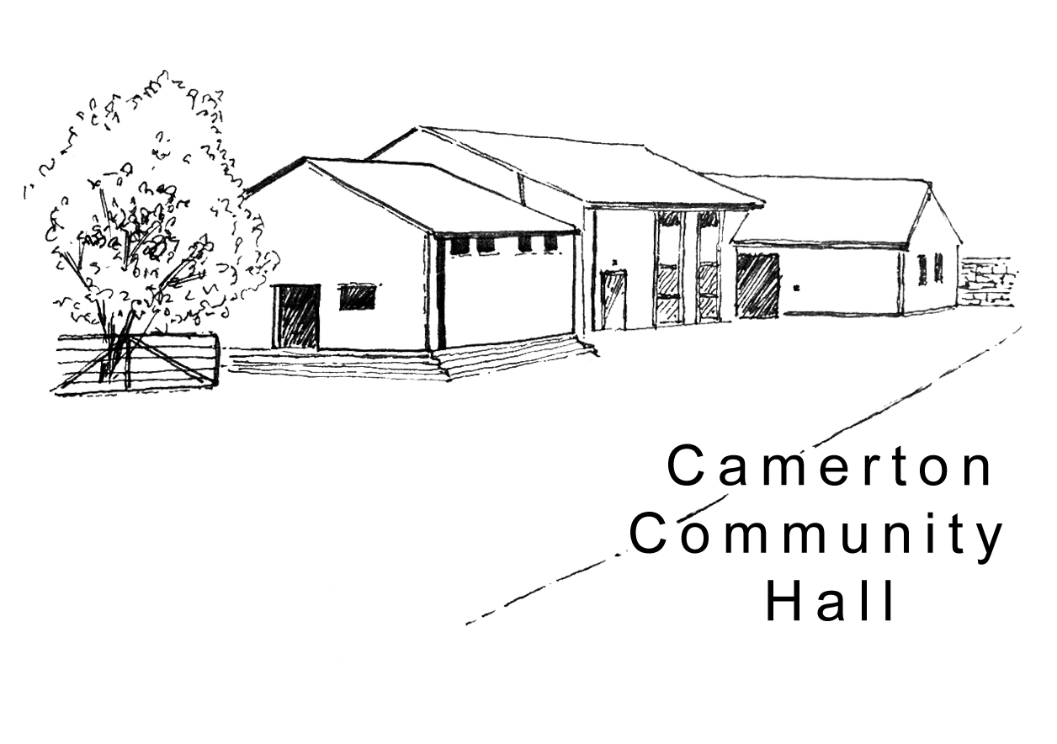
Camerton Community Hall
Registered Charity No. 308263

Organised Rally Single Camping Unit Pitch Rental 2019/20
Designed for individual guests to complete and the Organiser/Individual to return DIRECT to the Treasurer with full payment.

1. EVENT DETAILS

Name of Event: ………………………………………….. Date of Event: ………………………………….

2. UNIT/TENT OWNER

Name of Responsible Person: ...............................................................................................................

Address ...................................................................................................................................................

Landline: ................................. Mobile: ......................................Email: …………………………………...

2. DATE /TIME OF PITCH HIRE
Date of Arrival | Date of Departure

3. PITCH HIRE CHARGE (Reviewed Annually):
Facility | Booking Charge | Total
Single Pitch on field during Rally only | £8 per unit per night
Single Pitch on field during Rally with hire of Hall | £6 per unit per night
Electric Hook Up (5 units) | £3 per unit per night

Rental Payment will be made by: BACS (Preferred) [ ] Cheque [ ] CASH [ ]

4. PAYMENT TERMS
- Full Payment due with completed booking form in advance
- BACS payment to Nat West Bank, Sort Code: 60-14-24 Account Number: 32474628
- Cheque/s payable to Camerton Community Hall posted to address below
- Payment Reference – Pitch Rental’s name/responsible person, date of event

5. SAFEGUARDING
Camerton Community Hall is committed to safeguarding and promoting the welfare of children, young people and vulnerable adults and expects all hirers, trustees, members and volunteers to share this commitment.

6. NO DOGS: on hall property including the recreation field, car park and Colliers Copse areas, unless authorised.

7. DECLARATION
I confirm that I am over 18 and that I have read, understood and agree to observe and abide by the Code of Conduct with the Terms and Conditions of Hire of the Hall and Recreation Field (www.camertoncommunityhall.co.uk/rentals) and will be personally responsible for the safe conduct of my party and the activities that take place during our stay.

Signed: ...................................................... Print Name: ………………….…………………………..……… Date: ......................................

To secure booking: Complete form and return with full payment. PLEASE NOTE: If full payment for your camping is not received prior to the event, then you will not be allowed to pitch your tent/unit overnight.

Return to: Maggie Hutton, Treasurer, Longacre, Durcott Lane, Camerton, BA2 0QE, 01761 470954

Thank you. We hope you enjoy using our facilities and have a great stay
Camerton Community Hall, Meadgate, Camerton, BA2 0NL
www.camertoncommunityhall.co.uk
August 2019

